BCSE307P Compiler Design Lab
Innovative Project

MiniLang: A Complete Compiler and Stack Virtual Machine with an Interactive Learning Playground

by
Reg No  24BDS0255  24BDS0284  24BCE2847  24BDS0203 | Team Member Names  Ishu Raj  Parth Bagwe  Siddiqa  Tejas Sinha

Under the Supervision of
Prof. MUTHUNAGAI S U
Assistant Professor Sr. Grade-2
School of Computer Science Engineering and Information Systems



November 2026
- Abstract:
Compiler design is usually taught one phase at a time, on paper, while the compilers students actually use hide every intermediate step behind a single command. This project, MiniLang, closes that gap. MiniLang is a small imperative programming language with whole numbers, lists, functions, recursion, loops and input, together with a complete compiler for it, written from scratch in Python 3 using only the standard library and no parser or lexer generators.
A program passes through every classical phase: a lexer; a recursive-descent parser; semantic analysis with symbol tables; a static type checker; an intermediate representation of three-address code organised into basic blocks and a control-flow graph; data-flow analyses (constant propagation, liveness and definite assignment); an optimizer (constant folding, dead-store elimination, peephole optimisation and tail-call optimisation); a code generator; and a stack-based virtual machine with an instruction set of 30 opcodes. The front end recovers from errors, so a single run reports every mistake with its line number and a helpful hint.
A Flask web application makes each phase visible: a playground with a tab for every stage and a step-through debugger, a game of 21 graded levels, 12 lessons that teach the language, and 8 chapters that explain the compiler using its own source code. The implementation is verified by 339 automated unit tests, which run on every push through GitHub Actions.
Keywords: compiler design, lexical analysis, recursive-descent parsing, semantic analysis, type inference, data-flow analysis, code optimisation, stack virtual machine, educational software.
- Introduction:
2.1 Background
A compiler translates a program written in a source language into an equivalent program in a target language. The standard textbook treatment (Aho, Lam, Sethi and Ullman, Compilers: Principles, Techniques, and Tools) divides the work into a front end (lexical, syntax and semantic analysis), a middle end (intermediate code generation and machine-independent optimisation) and a back end (code generation). Each phase consumes the output of the one before it: characters become tokens, tokens become a syntax tree, the tree is checked and lowered to intermediate code, the intermediate code is optimised, and finally executable code is produced.
In a laboratory course these phases are usually met separately: a lexer is generated with Lex, a parser with Yacc, and optimisation algorithms are traced by hand on small examples. Production compilers do not help much either, because they show only the final output or an error message. Students therefore rarely see how the phases fit together, or what each phase's data structure looks like for a real program.
2.2 Problem statement
To design and implement a complete compiler for a small but non-trivial programming language, in which every phase is written by hand, is observable and can be explored interactively, so that the compiler works both as a real tool and as a teaching aid for compiler design.
2.3 Objectives
- Define a small imperative language, MiniLang, with a formal context-free grammar.
- Implement every phase from scratch, without generator tools: lexer, parser, semantic analyser, type checker, intermediate code generator, optimizer, code generator and virtual machine.
- Implement the textbook data-flow analyses on a control-flow graph, and use them both for warnings and for optimisation.
- Report errors precisely and recover from them, so that one run shows every mistake.
- Build a web interface that shows the output of every phase and lets the user step through execution.
- Verify correctness with an automated test suite, including tests that the optimizer never changes what a program does.
2.4 The MiniLang language
MiniLang is a dynamically typed language with two kinds of value, whole numbers and lists. Its syntax borrows from C and Python. Table 1 summarises the language.
Table 1: MiniLang at a glance.
Feature | Syntax | Example
Comments | # to the end of the line | # running total
Variables | name = expr; and += -= *= /= %= | total += x;
Arithmetic | + - * / % and unary - | (a + b) * 2
Comparison and logic | == != < > <= >=, and or not | x > 0 and not done
Output and input | print expr;, input name; | input n;
Conditionals | if … else if … else | if x > 0 { print x; }
Loops | while, C-style for, break, continue | for i = 0; i < n; i += 1 { … }
Functions | func name(params) { … }, return, recursion | func fact(n) { … }
Lists | literals, indexing, len(), append() | xs = [1, 2]; append(xs, 3);

Listing 1: A MiniLang program that prints the first factorials.
func fact(n) {
if n <= 1 { return 1; }
return n * fact(n - 1);
}
input count; # read a number
for i = 1; i <= count; i += 1 {
print fact(i);
}
- Novelty in Project:
Small compilers for teaching are common. What distinguishes MiniLang is that it implements the whole textbook pipeline, including the middle end that student projects usually leave out, and makes every intermediate result visible and interactive. The main contributions are:
- The whole pipeline, observable end to end. Tokens, the syntax tree, symbol tables, inferred types, three-address code with its control-flow graph, bytecode before and after optimisation, and an execution trace are shown side by side for the same program, linked by line numbers.
- A real middle end. Constant propagation (Kildall's iterative algorithm), liveness analysis and definite-assignment analysis run on the control-flow graph. Their results drive both warnings, such as dead stores and possibly undefined variables, and optimisations, and they are drawn on the graph in the interface.
- Type inference as a data-flow problem. The type checker treats a type as a set drawn from {number, list}, iterates to a fixed point across all functions, and reports only errors that are certain on every path, so it never rejects a correct program.
- Error recovery with helpful hints. The lexer skips invalid characters, the parser uses phrase-level recovery (inserting a missing semicolon) and panic-mode recovery, and semantic analysis keeps going, so one run reports every error. Messages suggest corrections for misspelt keywords and names ("did you mean 'while'?") and for syntax borrowed from other languages, such as && instead of and.
- Optimisations proven safe by testing. Tests run tricky programs with the optimizer on and off and require identical output, or the identical error on the same line. Tail-call optimisation lets tail recursion 5,000 calls deep run in constant stack space, where the unoptimised program exceeds the call depth limit.
- A step-through debugger that runs backwards. The virtual machine records every instruction it executes, so the user can step forwards and backwards and inspect the operand stack and every call frame at each step.
- Learning by playing. Twenty-one levels, 13 programming challenges and 8 "bug hunts" (one for each kind of error), are checked against hidden tests. Stars are awarded from the compiler's own metrics, optimised bytecode size and virtual-machine steps, so players learn why one solution is faster than another.
- Documentation that cannot go stale. The 8 compiler chapters quote the compiler's source directly from its files using Python's ast module, and the examples in the 12 language lessons are compiled and run when the page is rendered. A test fails if a quote or an example no longer matches the code.
- No dependencies, works offline. The compiler uses only the Python standard library; Flask is needed for the website alone, and the website serves all of its assets itself.
Table 2 compares MiniLang with tools commonly used to explore compilers and programs.
Table 2: Comparison with existing tools.
Tool | What it shows | What it does not show
Compiler Explorer | Assembly, and some intermediate dumps, from production compilers | Execution; industrial compilers' output is too large to follow phase by phase
AST Explorer | The syntax tree produced by many existing parsers | Semantic analysis, intermediate code, optimisation or execution
Python Tutor | Step-by-step execution with variables and call frames | Any compilation phase
Lex / Yacc exercises | Generated lexers and parsers | The middle and back end; the generated code is hard to read
MiniLang | Every phase from characters to an execution trace, for the same program | Scope is deliberately small: a teaching language, not a production one

- Proposed Work:
4.1 System architecture
The system has two layers (Figure 1). The compiler is a pipeline of independent modules: each phase is one Python file that consumes the previous phase's output and produces a well-defined data structure. Any phase can report errors, and every error records its phase and source line. The web application (api.py and app.py) runs the same pipeline and returns every phase's output as JSON, which the browser renders. The browser never compiles anything itself.
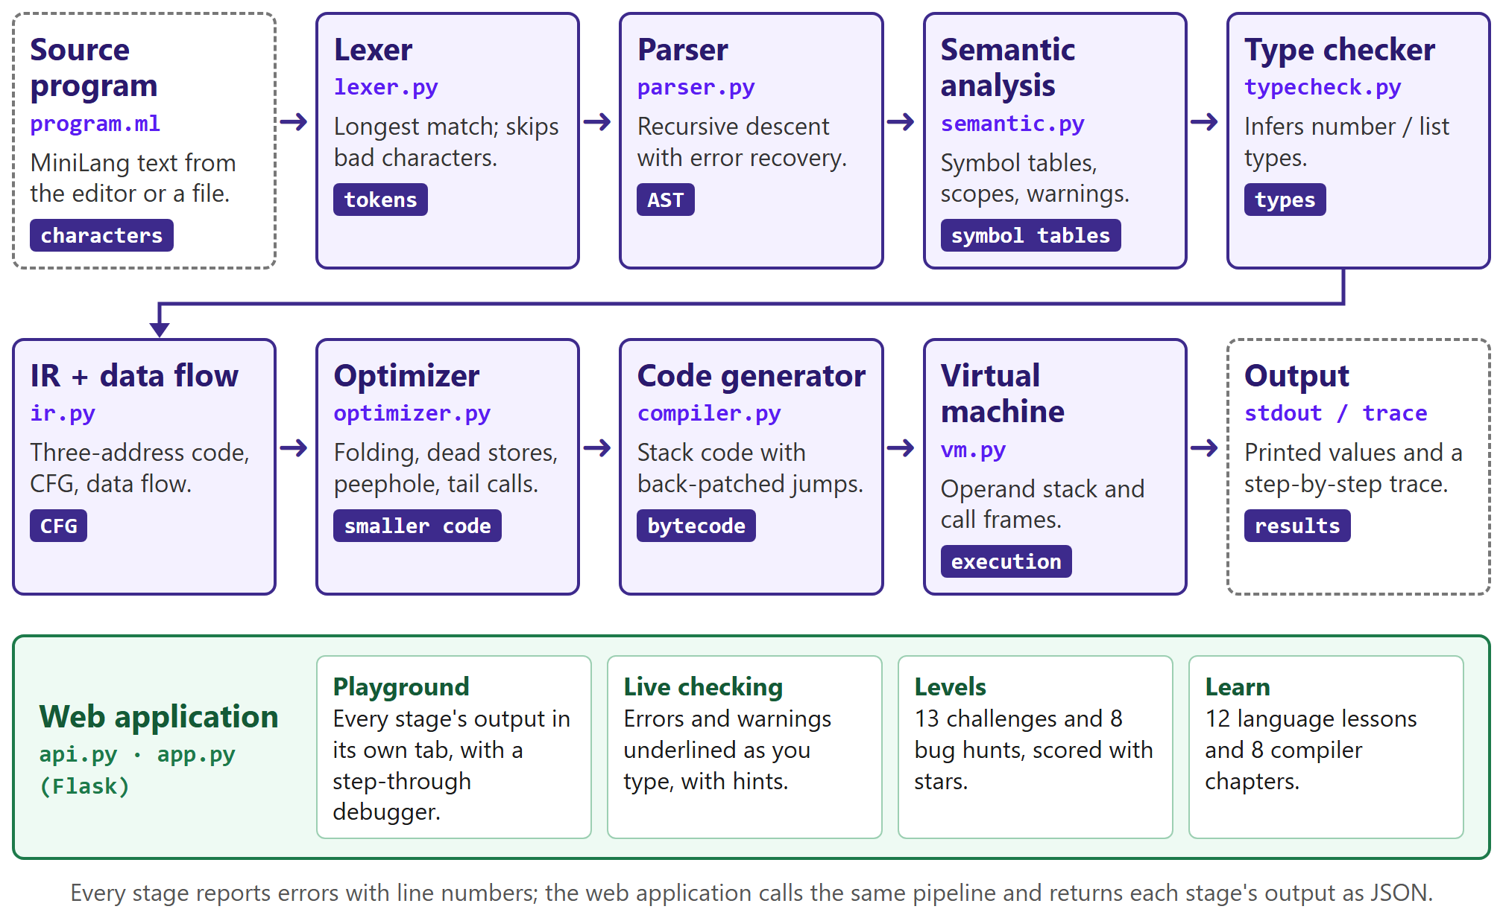
Figure 1: System architecture: the compiler pipeline and the web application.
4.2 Grammar
The syntax is defined by a context-free grammar (Listing 2) designed so that one token of lookahead, or two for a function call, always decides which rule applies. This makes it suitable for recursive descent. Operator precedence is encoded by layering: each precedence level is a separate rule that parses its operands with the next, tighter level, and a loop within each rule makes the operators left-associative.
Listing 2: MiniLang grammar, from lowest to highest precedence.
program := (funcdef | statement)* EOF
funcdef := "func" IDENT "(" (IDENT ("," IDENT)*)? ")" block
statement := assignment ";" | "print" expr ";" | "input" IDENT ";" | call ";"
| "if" expr block ("else" (if | block))?
| "while" expr block
| "for" assignment? ";" expr? ";" assignment? block
| "return" expr? ";" | "break" ";" | "continue" ";" | block
assignment := IDENT ("[" expr "]")* ("=" | "+=" | "-=" | "*=" | "/=" | "%=") expr
block := "{" statement* "}"
expr := and_expr ("or" and_expr)*
and_expr := not_expr ("and" not_expr)*
not_expr := "not" not_expr | comparison
comparison := additive (("=="|"!="|"<"|">"|"<="|">=") additive)?
additive := term (("+"|"-") term)*
term := unary (("*"|"/"|"%") unary)*
unary := "-" unary | postfix
postfix := primary ("[" expr "]")*
primary := INT | call | IDENT | "(" expr ")" | "[" (expr ("," expr)*)? "]"
call := IDENT "(" (expr ("," expr)*)? ")"
4.3 Design of each phase
a) Lexical analysis (lexer.py)
The lexer scans the source one character at a time with one character of lookahead and applies the longest-match rule, so <= is read as one operator rather than < followed by =. Words are checked against the keyword table to separate keywords from identifiers. Each token records its type (INT, IDENT, KEYWORD, OP or EOF), its value and its line number. An unexpected character is reported and skipped, so lexing continues and every bad character is found in one run.
b) Syntax analysis (parser.py)
A hand-written recursive-descent parser has one method per grammar rule and builds an abstract syntax tree (AST) whose nodes keep their source line. Compound assignments such as x += e are desugared to x = x + e here, so later phases never see them. On an error the parser either inserts a missing ; at the end of a line (phrase-level recovery) or skips to the start of the next statement (panic-mode recovery). It keeps at most one error per line and stops after 20.
c) Semantic analysis (semantic.py)
Two passes over the AST build the symbol tables. The first collects every function, so a function may be called before it is defined; the second resolves every name in its scope (global, or local to a function). It reports undefined variables and functions, wrong argument counts, break or continue outside a loop and return outside a function. It also warns about unused variables, unreachable code, dead stores, possibly undefined variables and the scope trap, where assigning to a global's name inside a function silently creates a local variable instead.
d) Type checking (typecheck.py)
MiniLang is dynamically typed, but many type errors can still be found before the program runs. The checker infers, for every variable at every point, the set of types it may hold, using a forward data-flow analysis over the control-flow graph whose join is set union. Parameter and return types are found by iterating over all the functions until nothing changes (an interprocedural fixed point). An error is reported only if an operation is wrong for every possible type, for example adding a number to a value that is certainly a list.
e) Intermediate representation and data-flow analysis (ir.py)
The AST is lowered to three-address code, in which every instruction has at most one operator, using compiler-generated temporaries (t1, t2, …). The code is divided into basic blocks at leaders (the first instruction, every label and every instruction after a jump), and the blocks are joined into a control-flow graph (CFG). Three analyses run on the graph:
- Constant propagation (forward, Kildall's algorithm): a variable is constant at a block's entry only if every predecessor agrees on its value. Branches whose condition is constant prune the edges that can never be taken.
- Liveness (backward): live_in(B) = use(B) ∪ (live_out(B) − def(B)), where live_out(B) is the union of live_in over B's successors. A store to a variable that is not live afterwards is a dead store.
- Definite assignment (forward, a must analysis with intersection at joins): finds reads that may happen before any assignment on some path.
f) Optimisation (optimizer.py)
The optimizer runs four passes. Constant propagation replaces reads of proven constants with their values. Constant folding evaluates constant expressions at compile time, but never one that would fail, such as a division by zero, so the runtime error is kept. Dead-store elimination removes stores whose value is never read, provided computing the value cannot fail. A peephole pass removes branches with constant conditions, threads jumps that lead to other jumps, deletes unreachable code, and turns a CALL immediately followed by RET into TAIL_CALL, which reuses the current frame.
g) Code generation (compiler.py)
The code generator walks the AST in post-order, emitting instructions for a stack machine: the operands are pushed before their operator is applied. Forward jumps for if, while, for, break, continue and function calls are emitted with a placeholder target and back-patched once the target address is known. and and or are compiled with short-circuit jumps. The program is laid out as the top-level code, a HALT instruction, and then each function body.
h) Virtual machine (vm.py)
The virtual machine runs a fetch-decode-execute loop over the bytecode, with an operand stack and a call stack of frames; each frame holds a function's local variables and its return address. It checks the types of values at run time and enforces limits on steps, printed lines and call depth, so that no program, including one sent from a browser, can run forever. A hook called after every instruction records the trace used by the step-through debugger. Table 3 lists the instruction set.
Table 3: The 30 instructions of the MiniLang virtual machine.
Group | Instructions
Stack and variables | PUSH, LOAD, STORE, POP
Arithmetic | ADD, SUB, MUL, DIV, MOD, NEG
Comparison and logic | EQ, NE, LT, GT, LE, GE, NOT
Control flow | JUMP, JUMP_IF_FALSE, CALL, TAIL_CALL, RET, HALT
Lists | BUILD_LIST, INDEX, STORE_INDEX, LEN, APPEND
Input and output | PRINT, INPUT

4.4 Web application
The website is a Flask application in three parts: a landing page that introduces the project with a live self-test and an animated stack machine; the playground, where code is written and every phase is shown; and the learning section, with lessons on the language and chapters on the compiler. Table 4 lists its routes.
Table 4: Routes of the web application.
Route | Method | Purpose
/ | GET | Landing page
/play | GET | Playground; ?example=, ?code= and #level= open a program or a level directly
/learn, /learn/language/<lesson>, /learn/<chapter> | GET | Learning section: lessons and chapters
/run | POST | Compile and run a program; returns every phase's output and the execution trace as JSON
/lint | POST | Static checks only, used for live error checking while typing
/check | POST | Run a level's hidden tests and award stars
/stage | POST | Run a snippet up to one phase, for the demos in the chapters

4.5 Testing strategy
Every phase has its own unit tests, written with Python's unittest module. On top of these, behaviour-preservation tests run a list of tricky programs with the optimizer on and off and require the same output, or the same error on the same line. Content tests check that every level's reference solution earns three stars, every lesson example produces the output its lesson describes, and every source quote in the chapters still points at real code. A GitHub Actions workflow runs the whole suite on every push.
- Implementation & Screenshots:
5.1 Tools and environment
Table 5: Tools and environment.
Component | Technology
Language | Python 3 (developed and tested on Python 3.13); the compiler uses only the standard library
Web framework | Flask 3
Front end | HTML, CSS and JavaScript with no framework; CodeMirror 5 for the code editor
Testing | Python unittest; GitHub Actions for continuous integration
Version control | Git and GitHub

5.2 Code organisation
Each phase lives in its own module, so a phase can be read, tested and explained on its own. Table 6 lists the modules; in total the project has about 4,650 lines of Python, plus 2,450 lines of tests.
Table 6: Python modules.
Module | Lines | Responsibility
lexer.py | 140 | Characters to tokens; skips and reports bad characters
parser.py | 409 | Recursive-descent parser, error recovery, keyword hints, += desugaring
ast_nodes.py | 152 | Syntax tree node classes; text and JSON dumps
semantic.py | 425 | Symbol tables, scope checks and warnings
typecheck.py | 286 | Type inference over the CFG; certain type errors
ir.py | 782 | Three-address code, basic blocks, CFG, data-flow analyses
optimizer.py | 297 | Propagation, folding, dead stores, peephole, tail calls
compiler.py | 330 | Bytecode generation with back-patching; disassembler
vm.py | 247 | Stack virtual machine, limits and tracing
errors.py | 51 | One error class per phase, each with a line number
main.py | 109 | Command line: --debug, --trace, --no-opt, --input
api.py | 214 | Runs the pipeline and returns every phase as JSON
app.py | 273 | Flask routes for the website
levels.py | 491 | The 21 levels, hidden tests and star scoring
guide.py, learn.py | 451 | Language lessons; compiler chapters, source quoting and demos

5.3 One program through every phase
The following output was produced by the command-line driver (python main.py example.ml --debug) for a four-line program. It shows the data structure each phase hands to the next.
Listing 3: Input program.
x = 6 * 7;
if x > 40 {
print x;
}
Listing 4: Lexer output (16 tokens, abbreviated).
Token(IDENT, 'x', line=1) Token(OP, '=', line=1)
Token(INT, 6, line=1) Token(OP, '*', line=1)
Token(INT, 7, line=1) Token(OP, ';', line=1)
Token(KEYWORD, 'if', line=2) Token(IDENT, 'x', line=2)
Token(OP, '>', line=2) Token(INT, 40, line=2)
... Token(EOF, None, line=5)
Listing 5: Parser output, the abstract syntax tree (condensed).
Program [line 1]
statements:
Assign(name='x') [line 1]
value:
BinOp(op='*') [line 1]
left: Number(value=6)
right: Number(value=7)
If(else_body=None) [line 2]
condition:
BinOp(op='>') [line 2]
left: Var(name='x')
right: Number(value=40)
then_body:
Block [line 2]
statements:
Print [line 3]
value: Var(name='x')
Listing 6: Semantic analysis (symbol table) and type checker output.
global scope:
x global assigned 1 read 2, 3
globals:
x number
Listing 7: Three-address code, basic blocks, constants and liveness.
3 basic blocks, 2 constant variable reads, 0 unreachable blocks
procedure main
B0 -> B1, B2
live in: - live out: x
x = 6 * 7
t1 = x > 40
if_false t1 goto L1
B1 -> B2 constants in: x=42
live in: x live out: -
print x
B2 (L1) -> exit constants in: x=42
live in: - live out: -
Listing 8: Bytecode before and after optimisation.
Before optimising (11): After optimising (3):
0000 PUSH 6 0000 PUSH 42
0001 PUSH 7 0001 PRINT
0002 MUL 0002 HALT
0003 STORE x
0004 LOAD x
0005 PUSH 40
0006 GT
0007 JUMP_IF_FALSE 10
0008 LOAD x
0009 PRINT
0010 HALT
Constant propagation proves that x is 42 in every block, so x > 40 is always true. Folding and the peephole pass then remove the comparison and the branch, and dead-store elimination removes the store to x, because after substitution nothing reads it. The virtual machine runs the three remaining instructions and prints 42.
5.4 Execution trace
With --trace, the virtual machine prints every instruction it executes with the operand stack after it. Listing 9 shows the start of the trace for print fact(5); using the recursive factorial from Listing 1: each CALL opens a new frame, visible as the growing call depth.
Listing 9: The start of an execution trace.
[0000] PUSH 5 stack=[5] ; line 5
[0001] CALL 4 stack=[5] ; line 5 in fact(n) (depth 1)
[0004] STORE n stack=[] ; line 1 in fact(n) (depth 1)
[0005] LOAD n stack=[5] ; line 2 in fact(n) (depth 1)
[0006] PUSH 1 stack=[5, 1] ; line 2 in fact(n) (depth 1)
[0007] LE stack=[0] ; line 2 in fact(n) (depth 1)
[0008] JUMP_IF_FALSE 11 stack=[] ; line 2 in fact(n) (depth 1)
[0011] LOAD n stack=[5] ; line 3 in fact(n) (depth 1)
[0012] LOAD n stack=[5, 5] ; line 3 in fact(n) (depth 1)
[0013] PUSH 1 stack=[5, 5, 1] ; line 3 in fact(n) (depth 1)
[0014] SUB stack=[5, 4] ; line 3 in fact(n) (depth 1)
[0015] CALL 4 stack=[5, 4] ; line 3 in fact(n) (depth 2)
...
5.5 Error reporting
Each phase reports errors with the phase name, the line and, where possible, a hint. Because the front end recovers, all the errors of one phase are reported together. Listing 10 shows the messages for four small faulty programs.
Listing 10: Error messages from the lexer, parser, semantic analysis and type checker.
x = 1
print x;
if x > 0 { print 2 }
-> ParseError at line 1: expected ';' after assignment, found 'print'
-> ParseError at line 3: expected ';' after print, found '}'
x = 5 && 3;
-> LexError at line 1: unexpected characters '&&' (MiniLang writes 'and' instead of '&&')
count = 1;
print cont;
-> SemanticError at line 2: undefined variable 'cont' (did you mean 'count'?)
xs = [1, 2];
print xs + 1;
n = 5;
print n[0];
-> TypeError at line 2: '+' needs two numbers, but 'xs' is a list
-> TypeError at line 4: 'n' is a number, so it can't be indexed with [ ]
5.6 Screenshots
Figures 2 to 13 show the web application. The playground's right-hand panel has one tab per phase; each tab shows that phase's output for the program in the editor on the left.
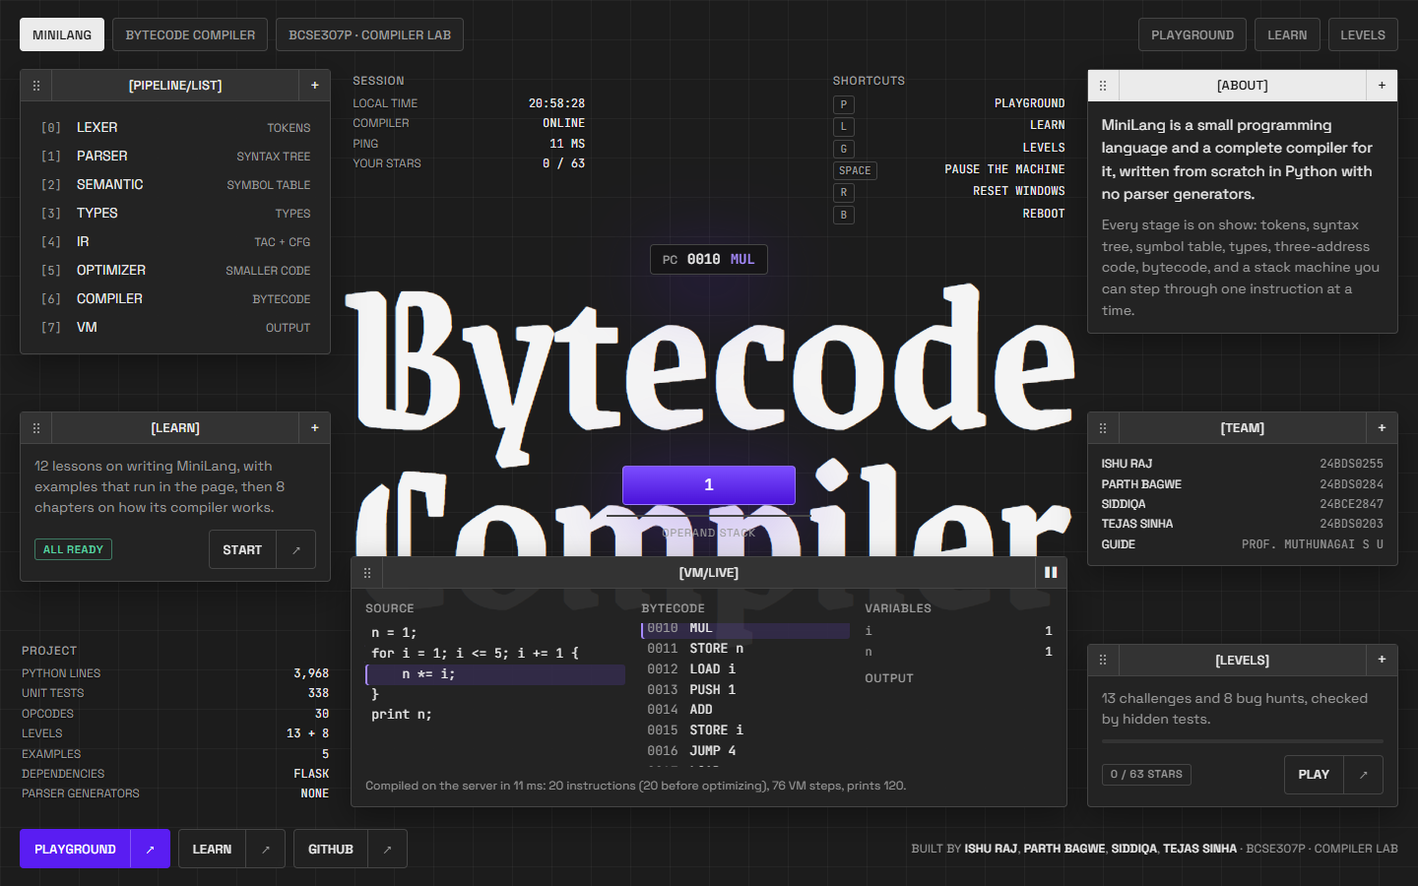
Figure 2: Landing page. The stack machine in the centre replays a real virtual-machine trace.
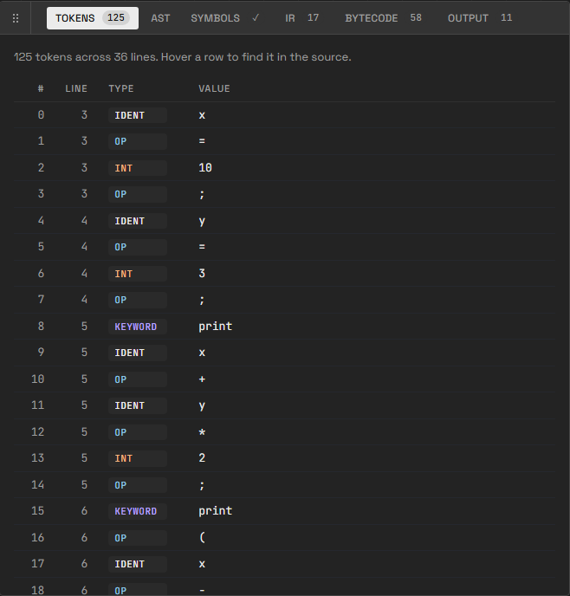
Figure 3: Playground, Tokens tab: the lexer's output.
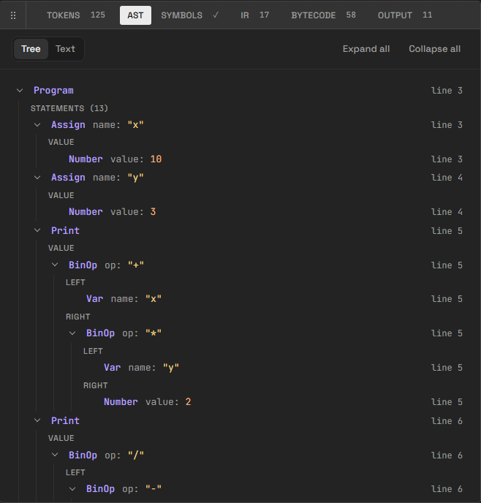
Figure 4: Playground, AST tab: the syntax tree, with the line of every node.
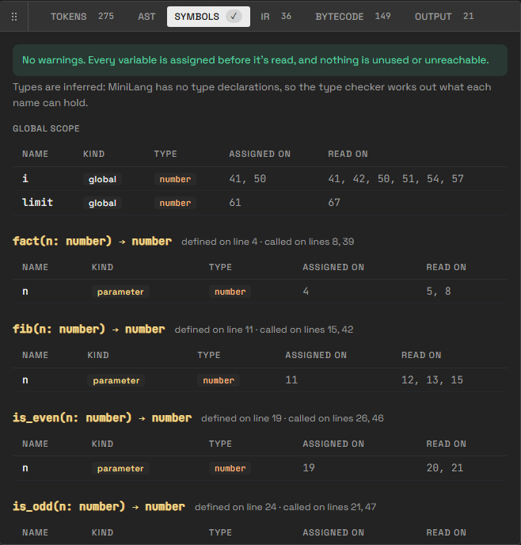
Figure 5: Playground, Symbols tab: symbol tables per scope, with inferred types and function signatures.
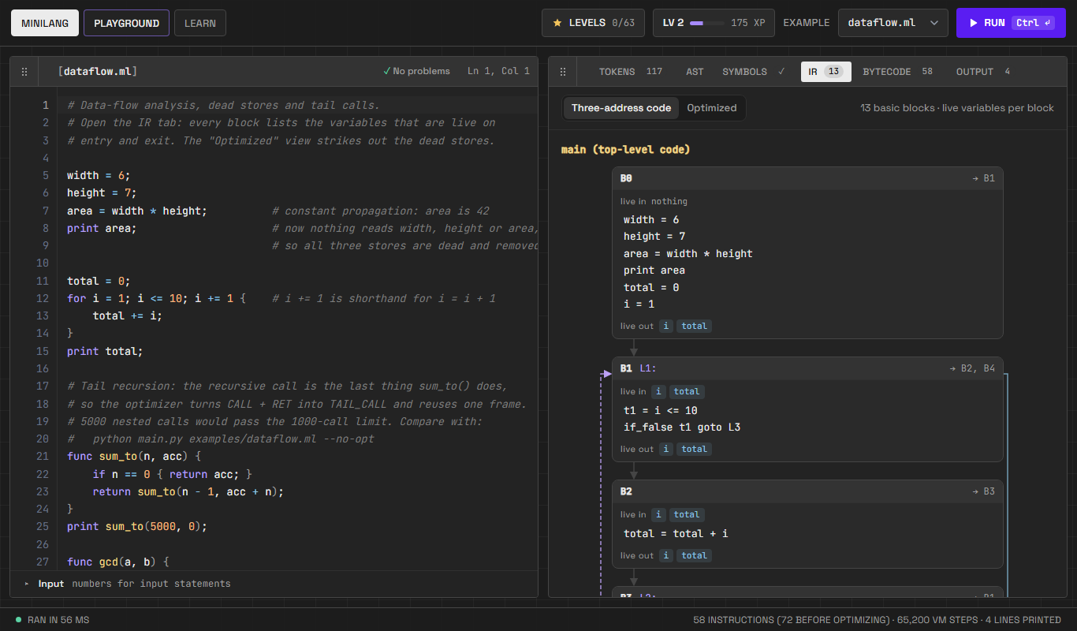
Figure 6: Playground, IR tab: basic blocks of three-address code joined into a control-flow graph, with the live variables on entry and exit of each block.
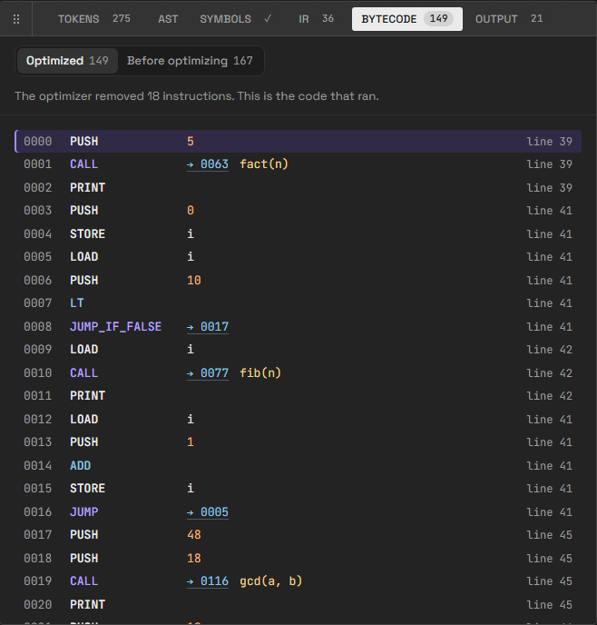
Figure 7: Playground, Bytecode tab: the optimised bytecode, with jump and call targets; a toggle shows the code before optimisation.
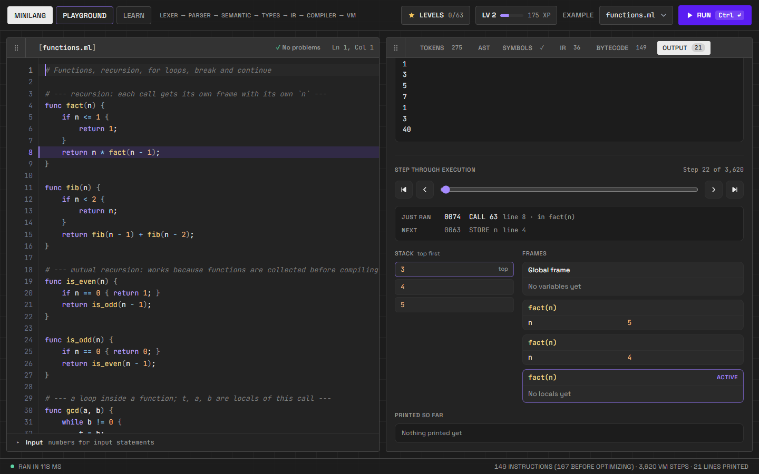
Figure 8: Playground, Output tab: stepping through execution. The operand stack and one frame per active call of the recursive factorial are shown.
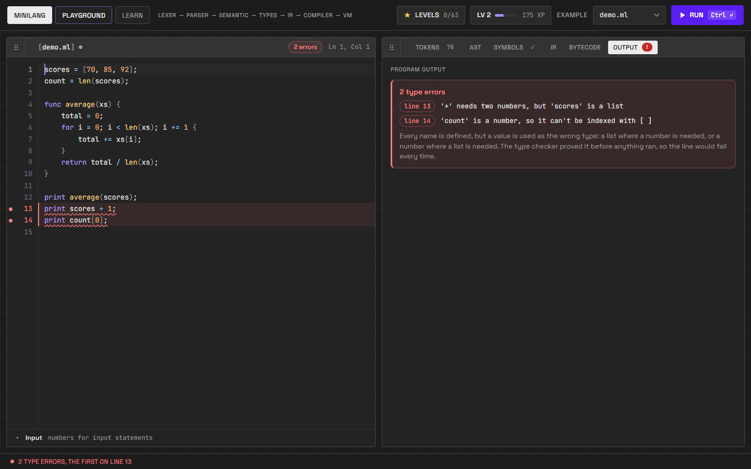
Figure 9: Live checking: type errors are underlined while typing, before the program is run.
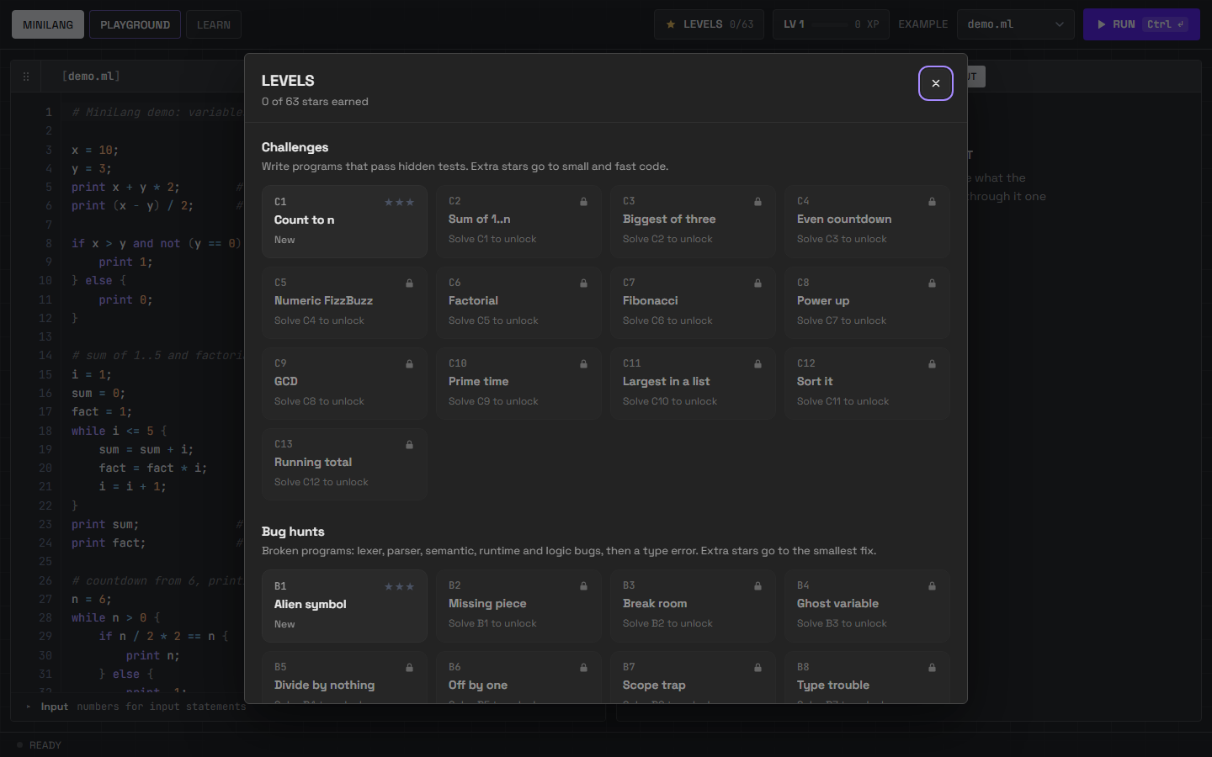
Figure 10: The level picker: 13 challenges and 8 bug hunts, each scored with up to three stars.
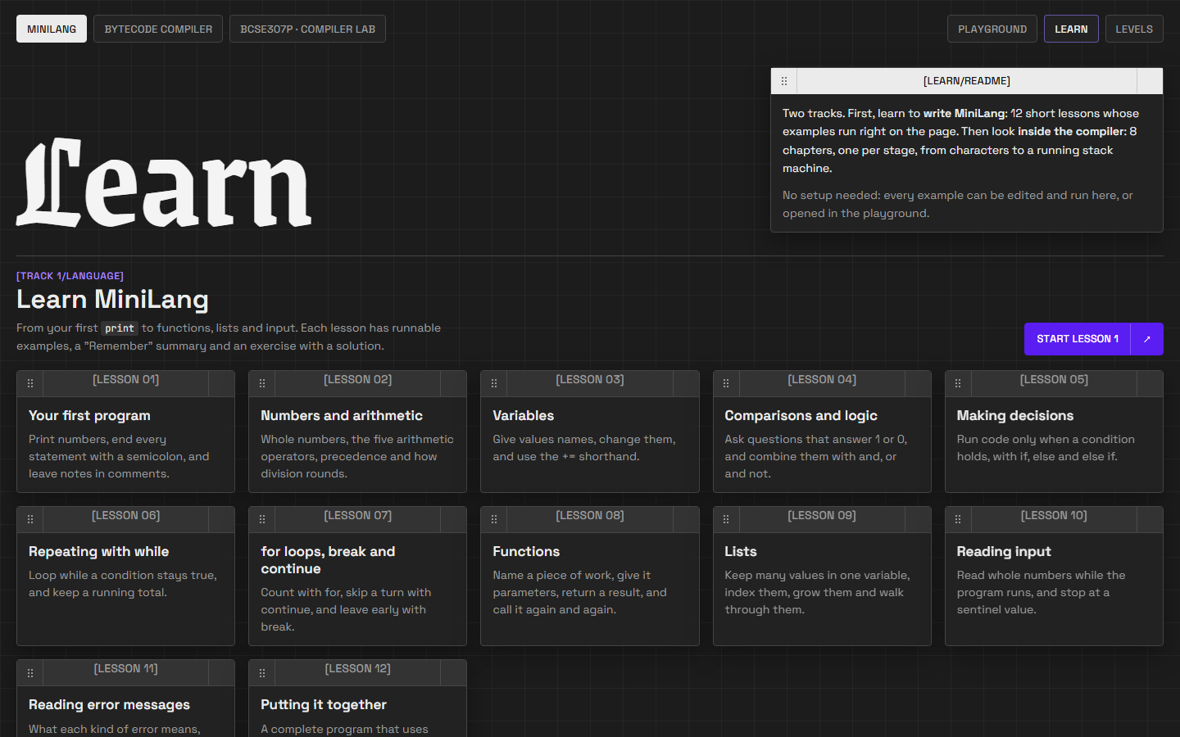
Figure 11: The learning section: two tracks, the language and the compiler.
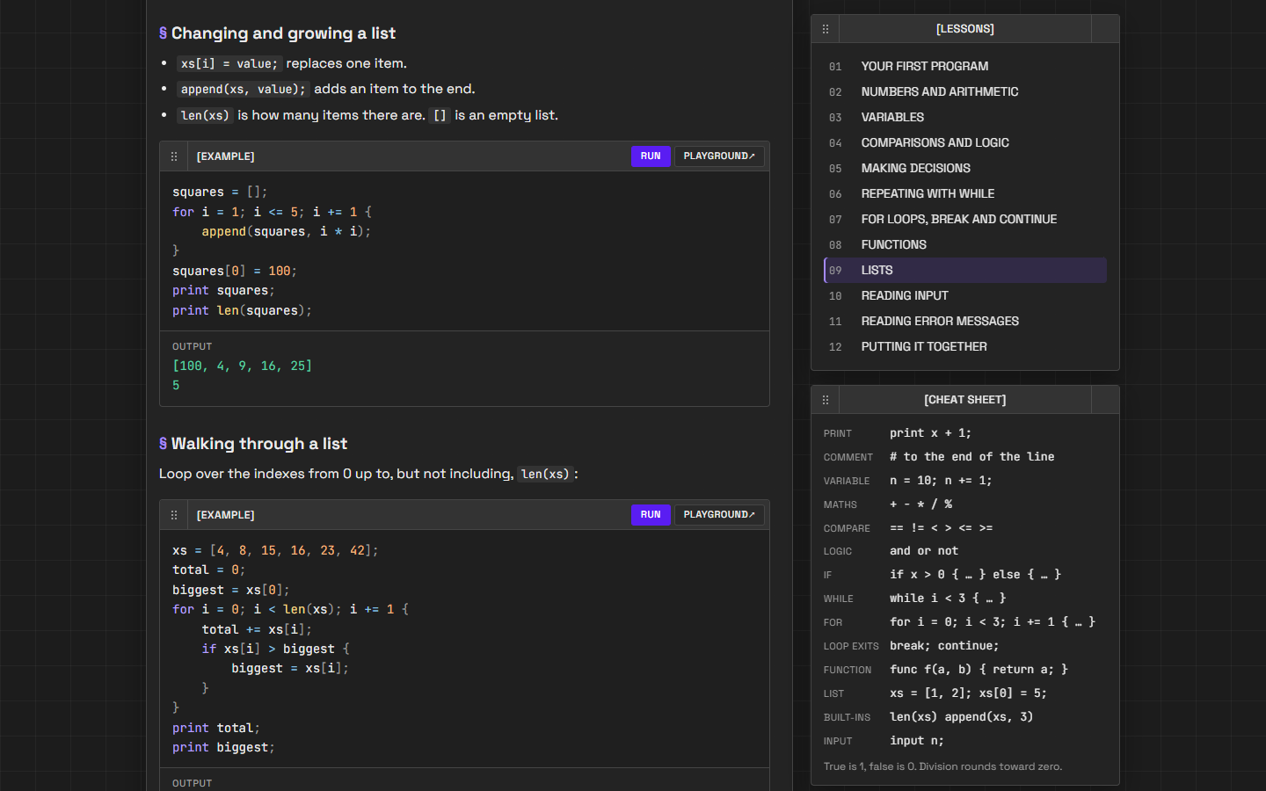
Figure 12: A language lesson. Every example is editable and runs through the real compiler.
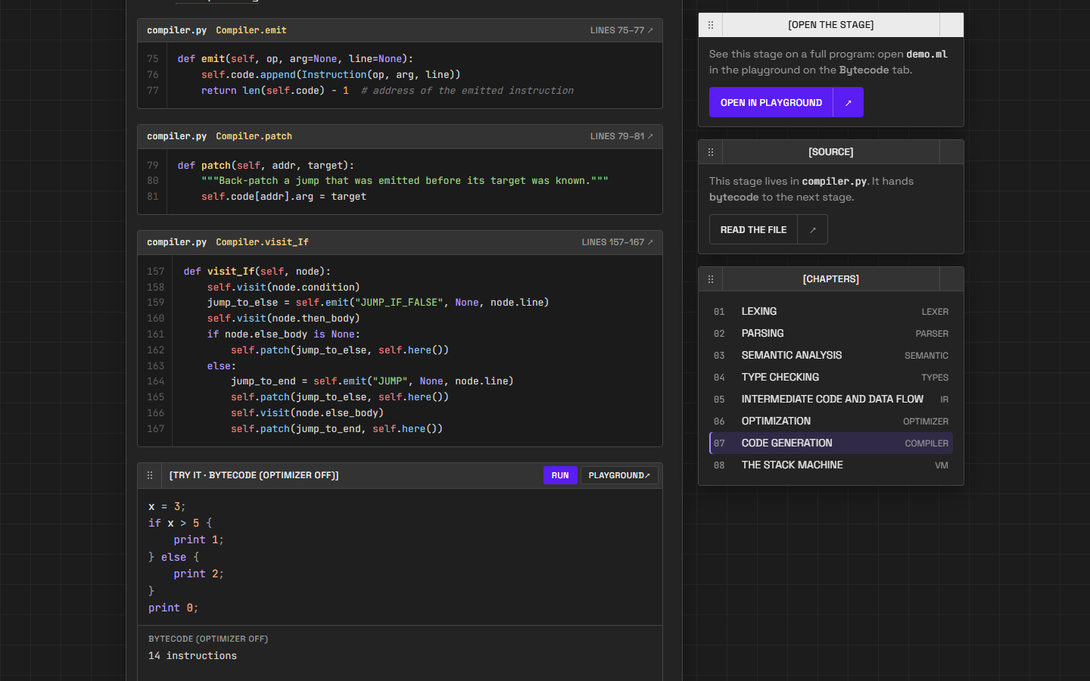
Figure 13: A compiler chapter, quoting the code generator's source directly from compiler.py.
5.7 Testing results
The test suite has 339 tests in 16 modules (Table 7). All of them pass, in about four seconds, both locally and on GitHub Actions.
Table 7: Test modules.
Test module | Tests | What it covers
test_lexer, test_parser | 24 | Tokens, longest match, precedence, associativity, syntax errors
test_recovery | 28 | Every lexer, parser and semantic error found in one run; hints
test_semantic | 25 | Symbol tables, scopes, warnings, the scope trap
test_typecheck | 22 | Inferred types; errors only when certainly wrong
test_ir | 23 | Three-address code, basic blocks, CFG, constants, liveness
test_optimizer | 32 | Each optimisation; same behaviour with the optimizer on and off
test_compiler, test_vm | 44 | Bytecode, back-patching, runtime errors and limits
test_arrays, test_input | 37 | Lists and the % operator; the input statement
test_api, test_app | 54 | JSON pipeline, web routes, offline assets, error handling
test_levels | 20 | Every reference solution earns 3 stars; every starter fails as intended
test_guide, test_chapters | 30 | Every lesson example and chapter quote and demo is correct

Listing 11: Running the test suite.
> python -m unittest discover -s tests -t .
----------------------------------------------------------------------
Ran 339 tests in 3.706s
OK
- Conclusion:
MiniLang shows that a complete compiler, from characters to execution, can be built from scratch in a few thousand lines of readable code, and that every phase can be made visible. The project implements all the classical phases: lexical analysis, recursive-descent parsing, semantic analysis with symbol tables, static type inference, three-address code with basic blocks and a control-flow graph, constant propagation, liveness and definite-assignment analysis, constant folding, dead-store elimination, peephole and tail-call optimisation, code generation with back-patching, and a stack virtual machine. All of it is verified by 339 automated tests.
Building it taught us how strongly the phases depend on each other. The grammar had to be designed for one-token lookahead before the parser could be simple; the line numbers stored by the lexer are what make every later error message useful; and the optimizer is only safe because the data-flow analyses beneath it are sound. The web application, the levels and the learning section turn the compiler into a tool for teaching these ideas, which was the project's main aim.
6.1 Limitations
- MiniLang has only whole numbers and lists: there are no strings, floating-point numbers or records.
- The target is bytecode for our own virtual machine, not native machine code, so there is no register allocation or instruction selection.
- The optimizer works on one function at a time and does not yet move code out of loops.
6.2 Future work
- Add strings, floating-point numbers and records to the language and the type checker.
- Generate native code (for example x86-64, or LLVM IR) with register allocation by graph colouring.
- Convert the intermediate code to static single assignment (SSA) form and add loop-invariant code motion and common-subexpression elimination.
- Provide editor support through the Language Server Protocol, reusing the existing error recovery.
- Project Repository Link: (GitHub or drive link)
GitHub: https://github.com/ir1101/ByteCode
The repository contains the complete source code, the test suite, example programs and a README that documents every phase. To run the project:
Listing 12: Running MiniLang.
python -m pip install flask # the only dependency, for the website
python app.py # website on http://127.0.0.1:5000
python main.py examples/demo.ml --debug # every phase on the command line
python -m unittest discover -s tests -t . # run the 339 tests

